**DOCUMENTATION FOR TS GOT TALENT APP**

1. SCREENSHOTS

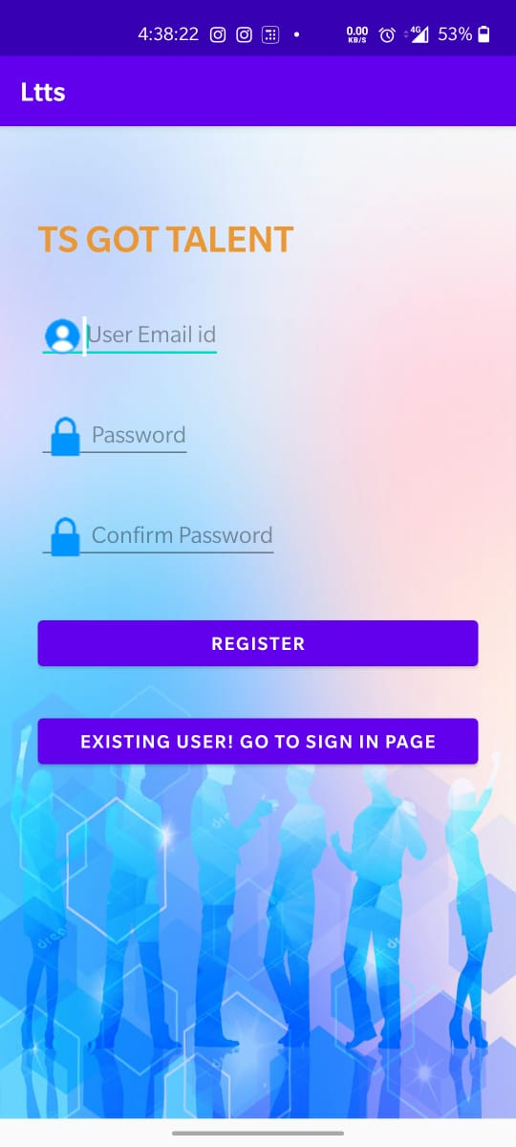 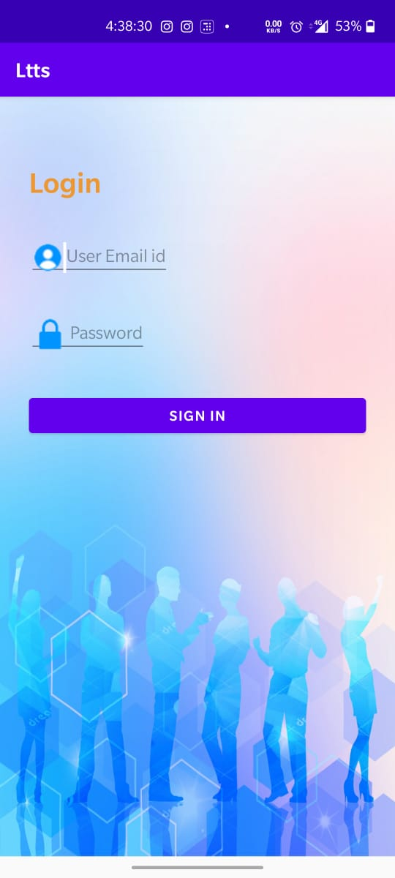

Fig 1: Resistration Activity Fig 2: Login Activity

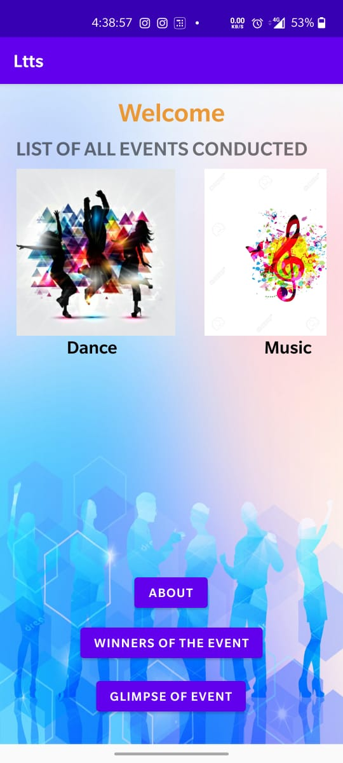 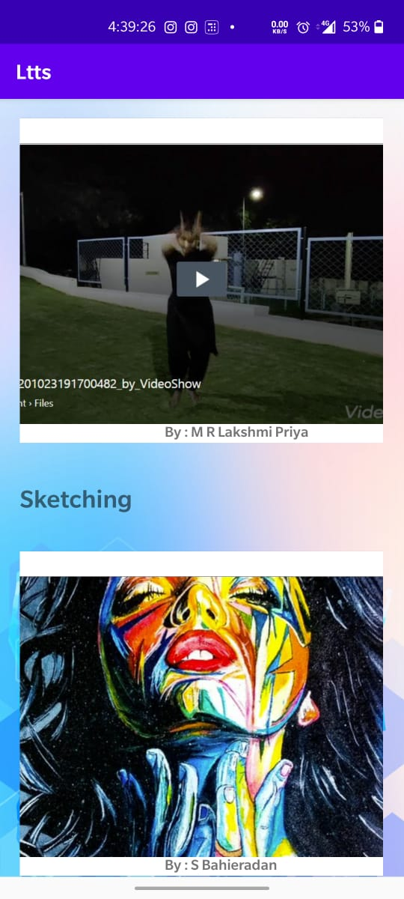

Fig 3: Welcome Activity Fig 4: Winners Activity

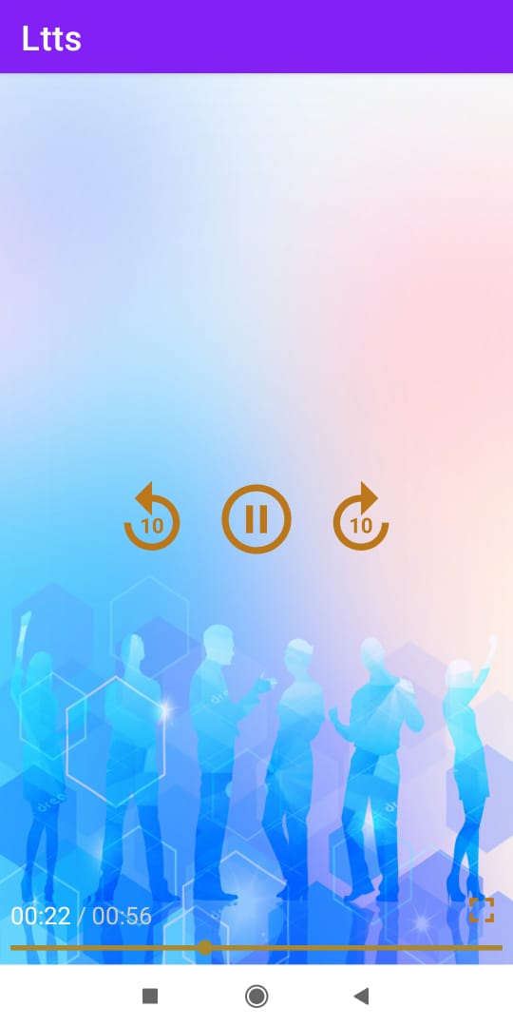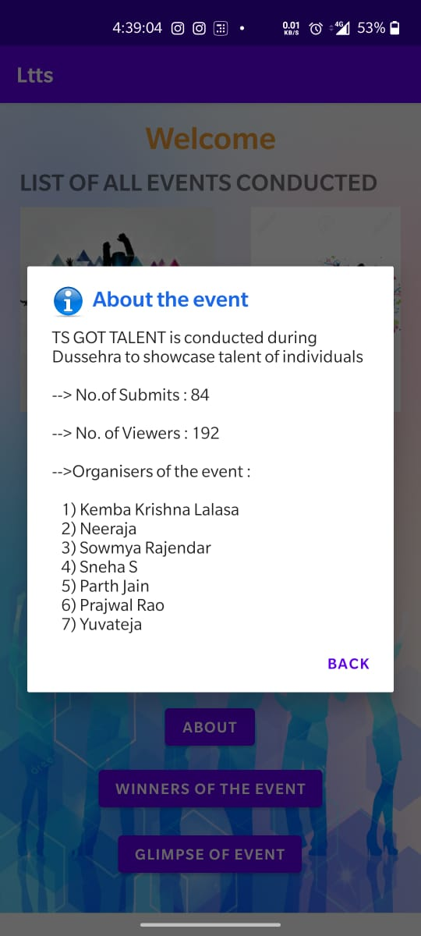

Fig 5: About the Event Fig 6: ExoPlayer

1. Link to APK : https://appetize.io/app/kz4vg6xpmwzx320yaftykxjjtm
2. Link to GitHub: <https://github.com/99002533/AndroidAssessment>